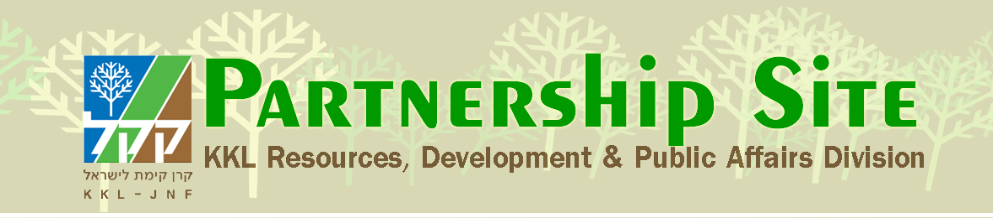
Jerusalem Day – 28 Iyar 5774
KKL-JNF and Jerusalem
A Long-Standing Commitment to Zionism
Today, in the seventh decade of the State of Israel, Jerusalem is home to some 804,000 people, of whom 63 percent are Jews, 35 percent, Muslims and 2 percent, Christians, who can all enjoy the numerous cultural, tourist and educational activities held in the country's capital throughout the year.
Even before the state was born, KKL-JNF was there to ensure its existence through purchasing land, establishing national institutions, creating urban parks, preserving heritage sites and supporting vulnerable populations.
With the continued growth of the metropolis during the last decade, Jerusalem has succeeded, with the help of the Israeli government, the Jerusalem Municipality, KKL-JNF, the Israel Nature and Parks Authority and the Jerusalem Development Authority, to reinforce and enhance the leisure and recreation opportunities in the green expanse which has merged into the Jerusalem Park. The park, a "Green Ring around the Golden City", improves the quality of life and protects the city's natural surroundings.
KKL-JNF is involved in developing Jerusalem in many, diverse ways with the help of KKL-JNF Friends throughout the world:
- Parks and forests in Jerusalem and its environs
Community forests are magnets for neighborhood and family activities. In addition to serving as leisure and recreation areas for the densely populated metropolitan, the open, landscaped spaces and nature preserve the environment and heritage values of the Jerusalem Hills. They include Park Gilo in the south, the forests of Pisgat Ze'ev and Neve Ya'akov in the north, the Ramot forests and the Jerusalem Forest in the west, and the Peace Forest in the city's east. Residents are partners in preserving their city's green lung, protecting it from encroaching development and holding community events and activities to plant and survey and discover rare species in need of conservation.

In the Aminadav Forest, in the west of the city, KKL-JNF has developed numerous heritage and leisure sites accessible to all. Hundreds of thousands of visitors enjoy the springs surrounded by ancient agricultural terraces, sports areas, a bicycle trail and picnic spots shaded by trees. Adjacent is Yad Kennedy, a memorial to John F. Kennedy, the 35th President of the United States and Visitors Center, which serves all those touring this special area.

The Jerusalem Park, created in recent years, covers some 3,750 acres and is important for the residents of the burgeoning Jerusalem metropolis. The park already offers a wide range of activities for families and visitors, both from the city and beyond, who can choose to enjoy the park by foot or bicycle. Among weekend and holiday activities are cycling events and experiential fairs that develop ecological awareness.

The Jerusalem corridor's nature sites attract visitors throughout the year: Sataf in the Judaean Hills is well known for its springs and ancient terrace agriculture, which has been restored and where cooperative activities for Jewish and Arab children are held to nurture environmental responsibility; Begin Park was created with emphasis on conservation and biodiversity; Rabin Park and Derech Burma, within it, focuses on heritage and the battle sites that took place before Israel's independence on the road to Jerusalem; the very popular Tel Aviv to Jerusalem Cycle Trail was a gift to Israel in honor of its 60th birthday. The trail connects Jerusalem and its forests with sites in the Shfela, the coastal plain and Tel Aviv.

- Helping the Hebrew University Grow
The Hebrew University and Bezalel were built on land purchased by KKL-JNF, which continues to help in the development and upgrading of the Botanical Gardens, both at the Mt. Scopus and the Givat Ram campuses. Projects include cultivating a unique collection of plants and developing the site for receiving large numbers of visitors. In the framework of its continuing support of academic research, scholarships are awarded to university researchers in the field of the history of Zionism, through the "Friends of Herzl" project, and to forestry and environmental studies at the Faculty of Agriculture, which serve as the KKL-JNF Forestry Division's basis of advised activities for the 21st century. In addition, a course of study in forestry has been established, to cultivate the foresters of the future.

- Education and Heritage
- Ammunition Hill – KKL-JNF is involved in landscape development at the memorial site for the soldiers who fell in one of the fiercest battles of the Six-Day War.
- KKL-JNF built the 9/11 Living Memorial in Jerusalem Park's Arazim Valley.
- KKL-JNF creates learning corner in schools and outdoor activity youth clubs.

- Old and New in Jerusalem
KKL-JNF helps cultivate sites of historic and educational significance for tourists from Israel and the world over:
- KKL-JNF developed and cultivated the garden at the President's Residence, where official events and ceremonies are held; the landscape emphasizes plants native to Israel and features an olive tree.
- KKL-JNF develops parks surrounding the Old City, open to all; supported the rehabilitation of Builders of Jerusalem Park and the historic building at Teddy Park.
- KKL-JNF developed the archaeological site from the period of the Judaean Kings at Ramat Rahel.

- KKL-JNF for the Community
KKL-JNF's support of Jerusalem's socio-economically disadvantaged populations contributes towards their quality of life and empowerment, from creating safe and secure infrastructures to developing parks and facilities for treatment and relaxation. KKL-JNF helps by
- preparing land for the establishment of the Givat HaMatos neighborhood for new olim from Ethiopia.
- developing activity yards tailored to the needs of children and young people with disabilities, creating supportive environments at the residential homes of ALUT in Gilo and Malcha for people with autism; the Ilanot School for severely disabled children; and Shef Yativ, an institution for severely disabled youth.
- creating a therapeutic garden for newborns with developmental needs at the Sha'arei Tzedek Hospital and an environmental Garden of Healing at the Hadassah Hospital on Mt. Scopus; a protected and shaded garden for patients and staff, with areas for treatments and relaxation.

