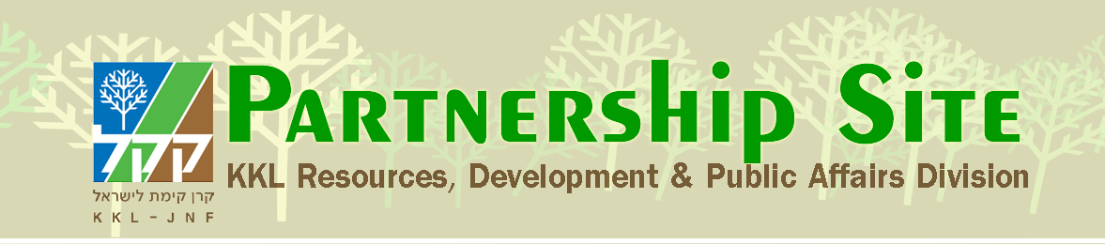
What’s New in the Jerusalem Park?
The vision of the metropolitan park steadily grows and takes shape from year to year with the assistance of KKL-JNF friends around the world. Today, you can see cultivated trees native to Israel, providing abundant shade and color throughout the seasons and enjoy walking and cycling along the respective trails. During the winter visitors can watch the water flow, revitalizing the valley. Those who prefer an extended stay can choose to rest or picnic in the shade of the pergolas, inhaling the intoxicating scent of native plants or seat themselves on the stone benches placed at scenic lookouts that afford views of the magical, green Jerusalem Hills landscape.

In the Arazim Valley
The first portion of the Sorek streambed has been rehabilitated and the family cycling trail has been completed with two scenic lookouts. Planting has also been carried out along the trail, which attracts groups and individuals, not only from the west of Jerusalem but also from throughout the country.
In the Motsa Valley
Renewed olives groves have been rehabilitated and an accessible cycling trail paved, with 6 patios that overlook orchards and the Beit Zayit Reservoir.
In the Refaim Valley
Stage 1 is in advanced implementation, with the establishment of promenades and parking areas, a cycling trail, tree-planting, landscaping and the installation of lighting, railings and shade pergolas. Playground equipment will be installed by the Moriah Company. When the work is complete, the residents of the southwestern part of the city will be able to reach this special recreation place easily by foot, car or on their bikes from neighborhoods both near and far.
A segment of the forest trail through Aminadav Forest has also been completed, inviting visitors to enjoy its leisure areas and historical sites.
The park's visitors are many and diverse, from sports enthusiasts (walking, running and cycling), families meandering through the valley on the trails connecting neighborhoods and busloads of tourists who can alight at the parking area built to receive large groups and people who are wheelchair bound.
The Jerusalem Municipality has adopted and continues to promote the park, recognizing its importance for the citizens of the crowded metropolis and nature itself. It invites all to join in the recreation and leisure options, including organized experiential nature and art activities, bird banding, special holiday happenings, sports and races. Independent visitors can receive suggested itineraries and are provided with explanatory brochures and guiding signage.

The Cycling Trail, which is a key element in this green park surrounding the entire city, links three valleys with their interesting sites, (except for short sections requiring safety infrastructure.) The project received good coverage this year through "Voyage around Jerusalem," in which cyclists rode through the Arazim Valley, the Motsa Valley, Emek Refaim and the wooded part of Amindav.
Ongoing Park Activities
Sunset in the Park: A series of midweek community events just before sunset continue to be held at the park’s most charming spots.
Spring in the Park: A wide variety of activities, including plays, crafts, projects for children, field cooking, walks and more. The events take place at Telem Springs National Park in the Arazim Valley.
Birds at the Spring: Bird banding in the Park: Once every month, the public is invited to take part in bird banding at Telem Springs National Park. Families and children play an interactive part in bird banding and take nature walks.

