
Marketing the Ring:
Themes and Highlights for Promoting the Jerusalem Ring Project
Workbook

Introduction
The Jerusalem Ring is an ambitious KKL-JNF project to develop a network of parks around Jerusalem that together will comprise the Jerusalem Metropolitan Park. The city is indeed beautiful and impressive, and it has developed rapidly in recent decades. The valleys to the north, west, and south of the city have come under pressure from extensive development, and the growing population lacks sufficient open space for recreation, sport, and leisure.
The mission of the Jerusalem Ring is to preserve, care for and develop the unique nature of Israel's capital. The project is modular and dynamic in its conception, goals, and content. In marketing the Jerusalem Ring you can find points of affinity and interest for every possible target group, as illustrated below.
We wish you all the best in your efforts. Your success will play a key role in shaping the future of the eternal city of Jerusalem in the twenty-first century.

The Jerusalem Ring: Vision
A network of parks will surround the city to the north, west, and south. The parks will buzz with life day and night, offering diverse leisure and recreation opportunities for residents of the city and for visitors from throughout Israel and abroad.
From vision to reality: Snapshots from the Jerusalem Ring
- It’s early on a weekday morning. A father and son set out on their bicycles and ride together. Leaving their neighborhood they pass along a section of the Jerusalem Ring Bicycle Trail. The son leaves the trail and rides up to his school. The father rides on another kilometer and branches off to his place of work.
- It’s Tuesday afternoon – a traditional time for youth movement activities. A group of youngsters meet with their counselor to explore the restored agricultural terraces in Arazim Valley Park. They help clean the area before moving on to a picnic site to play and enjoy refreshments.
- It’s Saturday morning. A Haredi mother from a neighborhood on the northwestern edge of the city takes her three young children into the park. They play on swings and slides as she rocks her baby to sleep in the stroller. A little later the father of the family comes along from synagogue with the older boys and the family enjoys some Sabbath peace in a shaded seating area.
- It’s a summer evening. A group of youngsters have texted each other during the day and arrange to meet by the boating lake. They hire pedal boats and race each other before sitting on the grass by the café with drinks and snacks. Late in the evening they ride or walk home along well-lit paths, passing late-night joggers.

Jerusalem Ring Marketing Goals
- To position KKL-JNF as the leading body behind the development of the Jerusalem Metropolitan Park. KKL-JNF brings a comprehensive approach that focuses equally on:
  - Nature and humans
  - Conservation and sustainable development
  - The heritage of the past, the needs of the present, and the vision for the future.
- To emphasize that the Jerusalem Ring is an anchor project on an unprecedented scale. The full weight of KKL-JNF’s expertise, prestige, and experience will be used to make sure the project is a success.
- To increase fundraising to KKL-JNF through the Jerusalem Ring Campaign.

Identification of the Market and Donor
Market identification must be oriented to the needs, fundraising techniques and cultural backgrounds of each country and each target population.
Fact – Donors from different countries and backgrounds view Jerusalem in different ways based on cultural predisposition.
- Show individual donors they can make a difference – what effect will the contribution have on the personal, community and countrywide level. It is important to bear in mind the current economic climate. Adopting an approach of 1 square meter can be yours for 50 dollars or euro, could be highly appropriate.
- Find the right target for your contribution. The Jerusalem Ring project includes a dazzling variety of action areas – planting, restoration and rehabilitation, leisure and recreation, ecology, tourism, cycling, heritage and education, tourism.
- Identify funds and foundations that identify with KKL-JNF's vision and goals
- Create links between people in the Jerusalem and communities where you are – schools, communities, businesses, faith-based organizations.

Match the message to the audience
- Traditional/religious Jewish orientation: Jerusalem as Israel’s eternal capital; Jerusalem as a city with a majority Jewish religious population; many of the neighborhoods bordering the parks are religious and Haredi; equality for religious and Haredi Jews (“religious Jews need parks, too”).
- Progressive/secular Jewish orientation: Jerusalem as a buzzing, modern city; Jerusalem kids want to skate and row; we don’t want malls open on the Sabbath in Jerusalem but kids need fun places to hang out; why should Tel Aviv always lead quality-of-life trends in Israel?!
- Zionist orientation: Jerusalem is under threat, we must guard and treasure it; the success of the Zionist enterprise will be secured in Jerusalem; improving quality of life for all in Jerusalem is a key to maintaining Israel’s interests in the city.
- Peace/coexistence orientation: The city of peace should live in peace; open space can encourage distinct population groups to live side by side in harmony and mutual respect; there’s room for everyone in the Jerusalem Ring; creating leisure opportunities for large families – Arab and Jewish.
- Christian orientation: Use Christian cultural themes (lion, ring, garden, peace); a Garden for His City.
- Ecological orientation: The park as a barrier to property sharks; a buffer zone of green around an expanding city; residents of the area in the past knew how to live and farm the area without depleting its resources – we must learn to do the same.
- Cycling: cycling as an ecological imperative; cycling to good health; cycling as a fun leisure-time activity – the family that cycles together laughs together.

How ?
Make KKL-JNF synonymous with the following:
- Market Jerusalem as “all things to all people” – as the eternal capital of the Jewish people; as Israel’s largest city; as the focus of the longings and prayers of the three Abrahamic faiths; as a multi-ethnic and multi-faith city; as the city of “air as clear as wine” that can become a model for ecological and environmental protection…
- Market the concept of sustainable development and balancing between development and preservation of open spaces
- Parks are not there for their own sake but for people, with all their diverse and changing needs
- Fundraising to repair and restore ancient agricultural terraces, springs, orchards, and other features
- Fundraising for a network of footpaths and for the Jerusalem Ring Bicycle Trail, which will link all the parks and form a complete circle around the city

Rationale of the Jerusalem Ring Campaign
- To create a modular package of values, goals, and projects appealing to diverse target populations and embodying the holistic nature of the project.
- To position the Jerusalem Ring Campaign as a unique, forward-looking, and positive drive. This time it isn’t about making do or repairing the damage of war or fires – it’s about creating something new, beautiful, and inspiring in a city that has a special place in all our hearts.

A. Campaign – general rationale
- KKL-JNF is committed to sustainable development and environmental responsibility.
- KKL-JNF is assuming leadership as an environmental organization on a local and global scale.
- Jerusalem, with its unique natural beauty and heritage on one hand and its rapid growth rate and diverse, young population on the other, is a perfect location for implementing sustainable development policies.
B. Jerusalem – specific rationale
- Jerusalem is at the center of countless circles – as Israel’s capital; as the heart of the Jewish people; as a cherished holy place for Muslims and Christians; as a vibrant seat for secular and sacred learning…
- Jerusalem is also one of Israel’s poorest cities, with high rates of overcrowding and poverty. Its daily reality fails to meet its lofty potential.
- The hills and valleys to the north, west, and south of the city include areas of great natural beauty and remnants of the unique agriculture that once flourished in the area.
- Jerusalem has enormous potential as a center for tourism and pilgrimage.
- Jerusalem’s population is a complex mosaic – Arabs and Jews; Christians, Muslims, and Jews; secular, traditional, religious, and Haredi Jews; large communities of immigrants speaking English, French, Russian, and other languages; disadvantaged neighborhoods and luxury housing projects…
- All residents of Jerusalem have the right to a decent quality of life and to leisure and recreation opportunities. Ensuring this right is also in Israel’s national and strategic interests.
- Jerusalem is the most important city for the Christian population worldwide - and an unparalleled focus for fundraising in Christian communities.
Why KKL-JNF ?
Making it clear why and how a contribution to the KKL-JNF Jerusalem Ring Campaign is so significant.
Why is KKL-JNF different from any other organization?
Emphasize at all times that KKL- JNF enjoys a time-honored institutional name and recognition and high degree of credibility.
A. Why?
What makes KKL-JNF different from any other organization?
- KKL-JNF is an organization focusing on a broad range of needs – from people to the environment.
- KKL-JNF can become involved in all facets of the parks: planning and implementation, restoration and renovation, heritage and education, development of footbaths and bicycle trails, and so on.
- KKL-JNF has the respect of all the bodies involved and can coordinate and focus efforts.

Therefore, KKL-JNF is best placed to develop the metropolitan parks for the benefit of present inhabitants and future generations.
B. How?
- Show that the Jerusalem Ring project will enhance Jerusalem’s status and improve the quality of life of its inhabitants.
- Show that KKL-JNF has the ability to lead a major anchor project in the city.
- Show that KKL-JNF has proven experience in planning, implementing, and coordinating projects relating to the development of parks; nature preservation; balancing nature and human activities; heritage and education; building bicycle paths, etc.

The Campaign Concept

General concept and themes
Jerusalem is beautiful. Its beauty must be protected and cherished and made more accessible to residents and visitors alike.
The Jerusalem Ring will form a fine entrance point to the city for those approaching from the west.
KKL-JNF will develop the metropolitan parks for the benefit of the people and the environment.
- Jerusalem is Israel’s capital, center, and showcase. It must be a leader in environmental protection and in quality of life.
- Changing times bring changing needs. Once we thought mainly of where we could build next; today we must also think about where not to build next.
- Jerusalem is possibly the most sensitive city in the world. Any major project in the city must be implemented with the utmost sensitivity and caution.

Develop strong campaign slogans
- Create new ones or slogans suited to your target population's specific needs.
- Connect the themes, slogan and logo of campaign to the potential contributor and market.
- Use the word “ring” in all its senses and associations as a running theme in your slogans.

Marketing Tools
 Names
Jerusalem MetroPark
Jerusalem Nature Park
Jerusalem Natural MetroPark
Jerusalem Metropolitan Nature Park
Jerusalem Hills MetroPark
A Green Ring for the city of Gold
The Jerusalem Metropolitan Park: A Green Ring for a Golden City
Circling the golden city with green
Embracing the golden city with green
Nurturing Jerusalem's natural resources and serene beauty

 Thematic slogans
1. Use the series of “ring” names:
- A Ring of Nature
- A Ring of Heritage
- A Ring of Recreation
- A Ring of Sport
- A Ring of Flora and Fauna
- A Ring of Hope

2. Alternative slogans:
- Adopt-a-Park: Help Nature For All
- The Nature of Our Future
- Be Outside, Be Educated, Be Healthy, Be Green, Be Involved
- Jerusalem Metropolitan Park: Clean, Safe, Natural
- Jerusalem Metropolitan Park: The Key to a Green Future

 Develop a powerful logo
Ideas for a mascot
The lion has long been associated with Jerusalem and features prominently in the city’s emblem.

Graphic concepts
Combine the elements of a lion and nature – a lion at ease in a park; stylized lions rowing boats on the lake, riding bicycles, jogging, playing on swings and slides and so on.

Slogan concepts
The Lion of Judah at rest again
Lion in the Park
The Lion’s Share of Beauty
The Lion’s Ring
Let the Lion Free / Let the Lion Roam / Let the Lion Roar…
 Newspaper ads / printed material
A series of advertisements with a common headline. Each ad details (in a few short sentences + graphic elements) one of the aspects of the park as listed on page 2. See page 3 for examples.
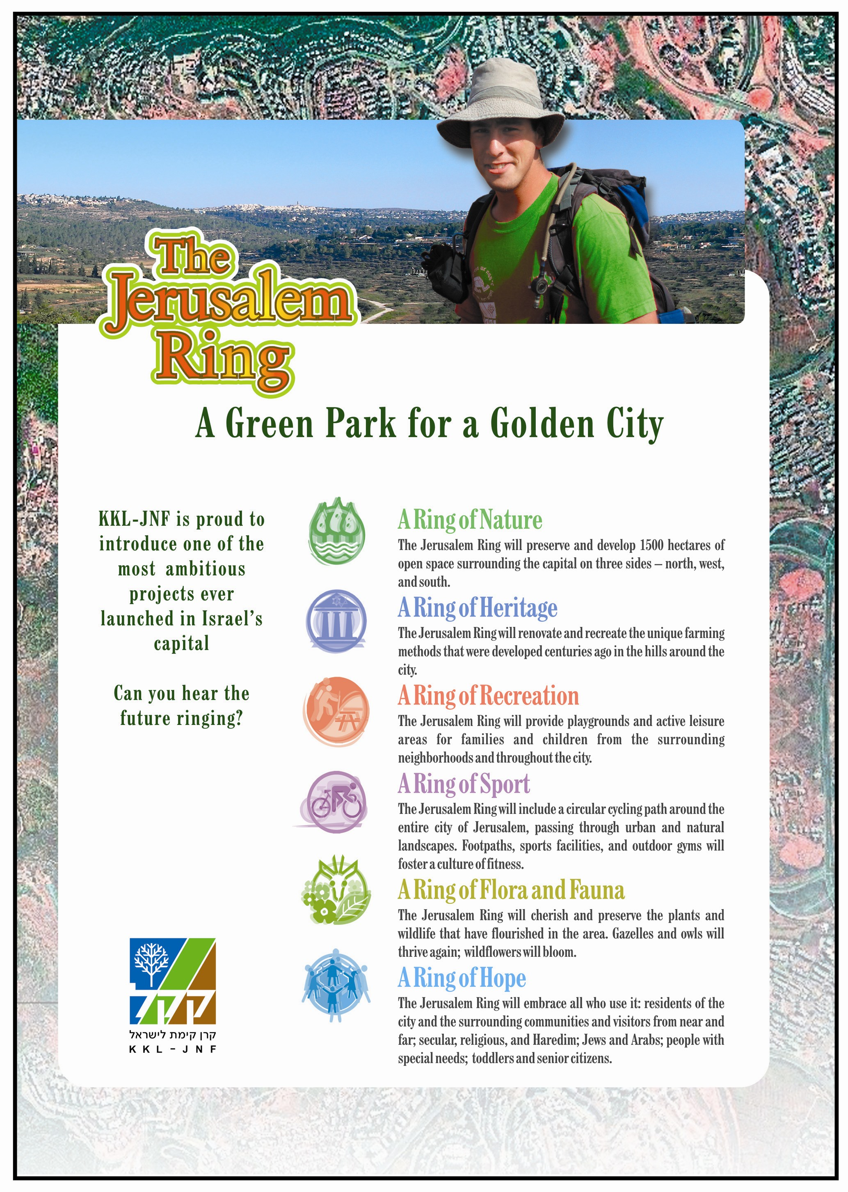
 Internet
All the different sections should be accessible from a home page. For example – each of the “rings” (nature, heritage, recreation, etc.) will appear on the home page in the form of a ring-shaped icon. When surfers click the ring it will open and provide information about that field.

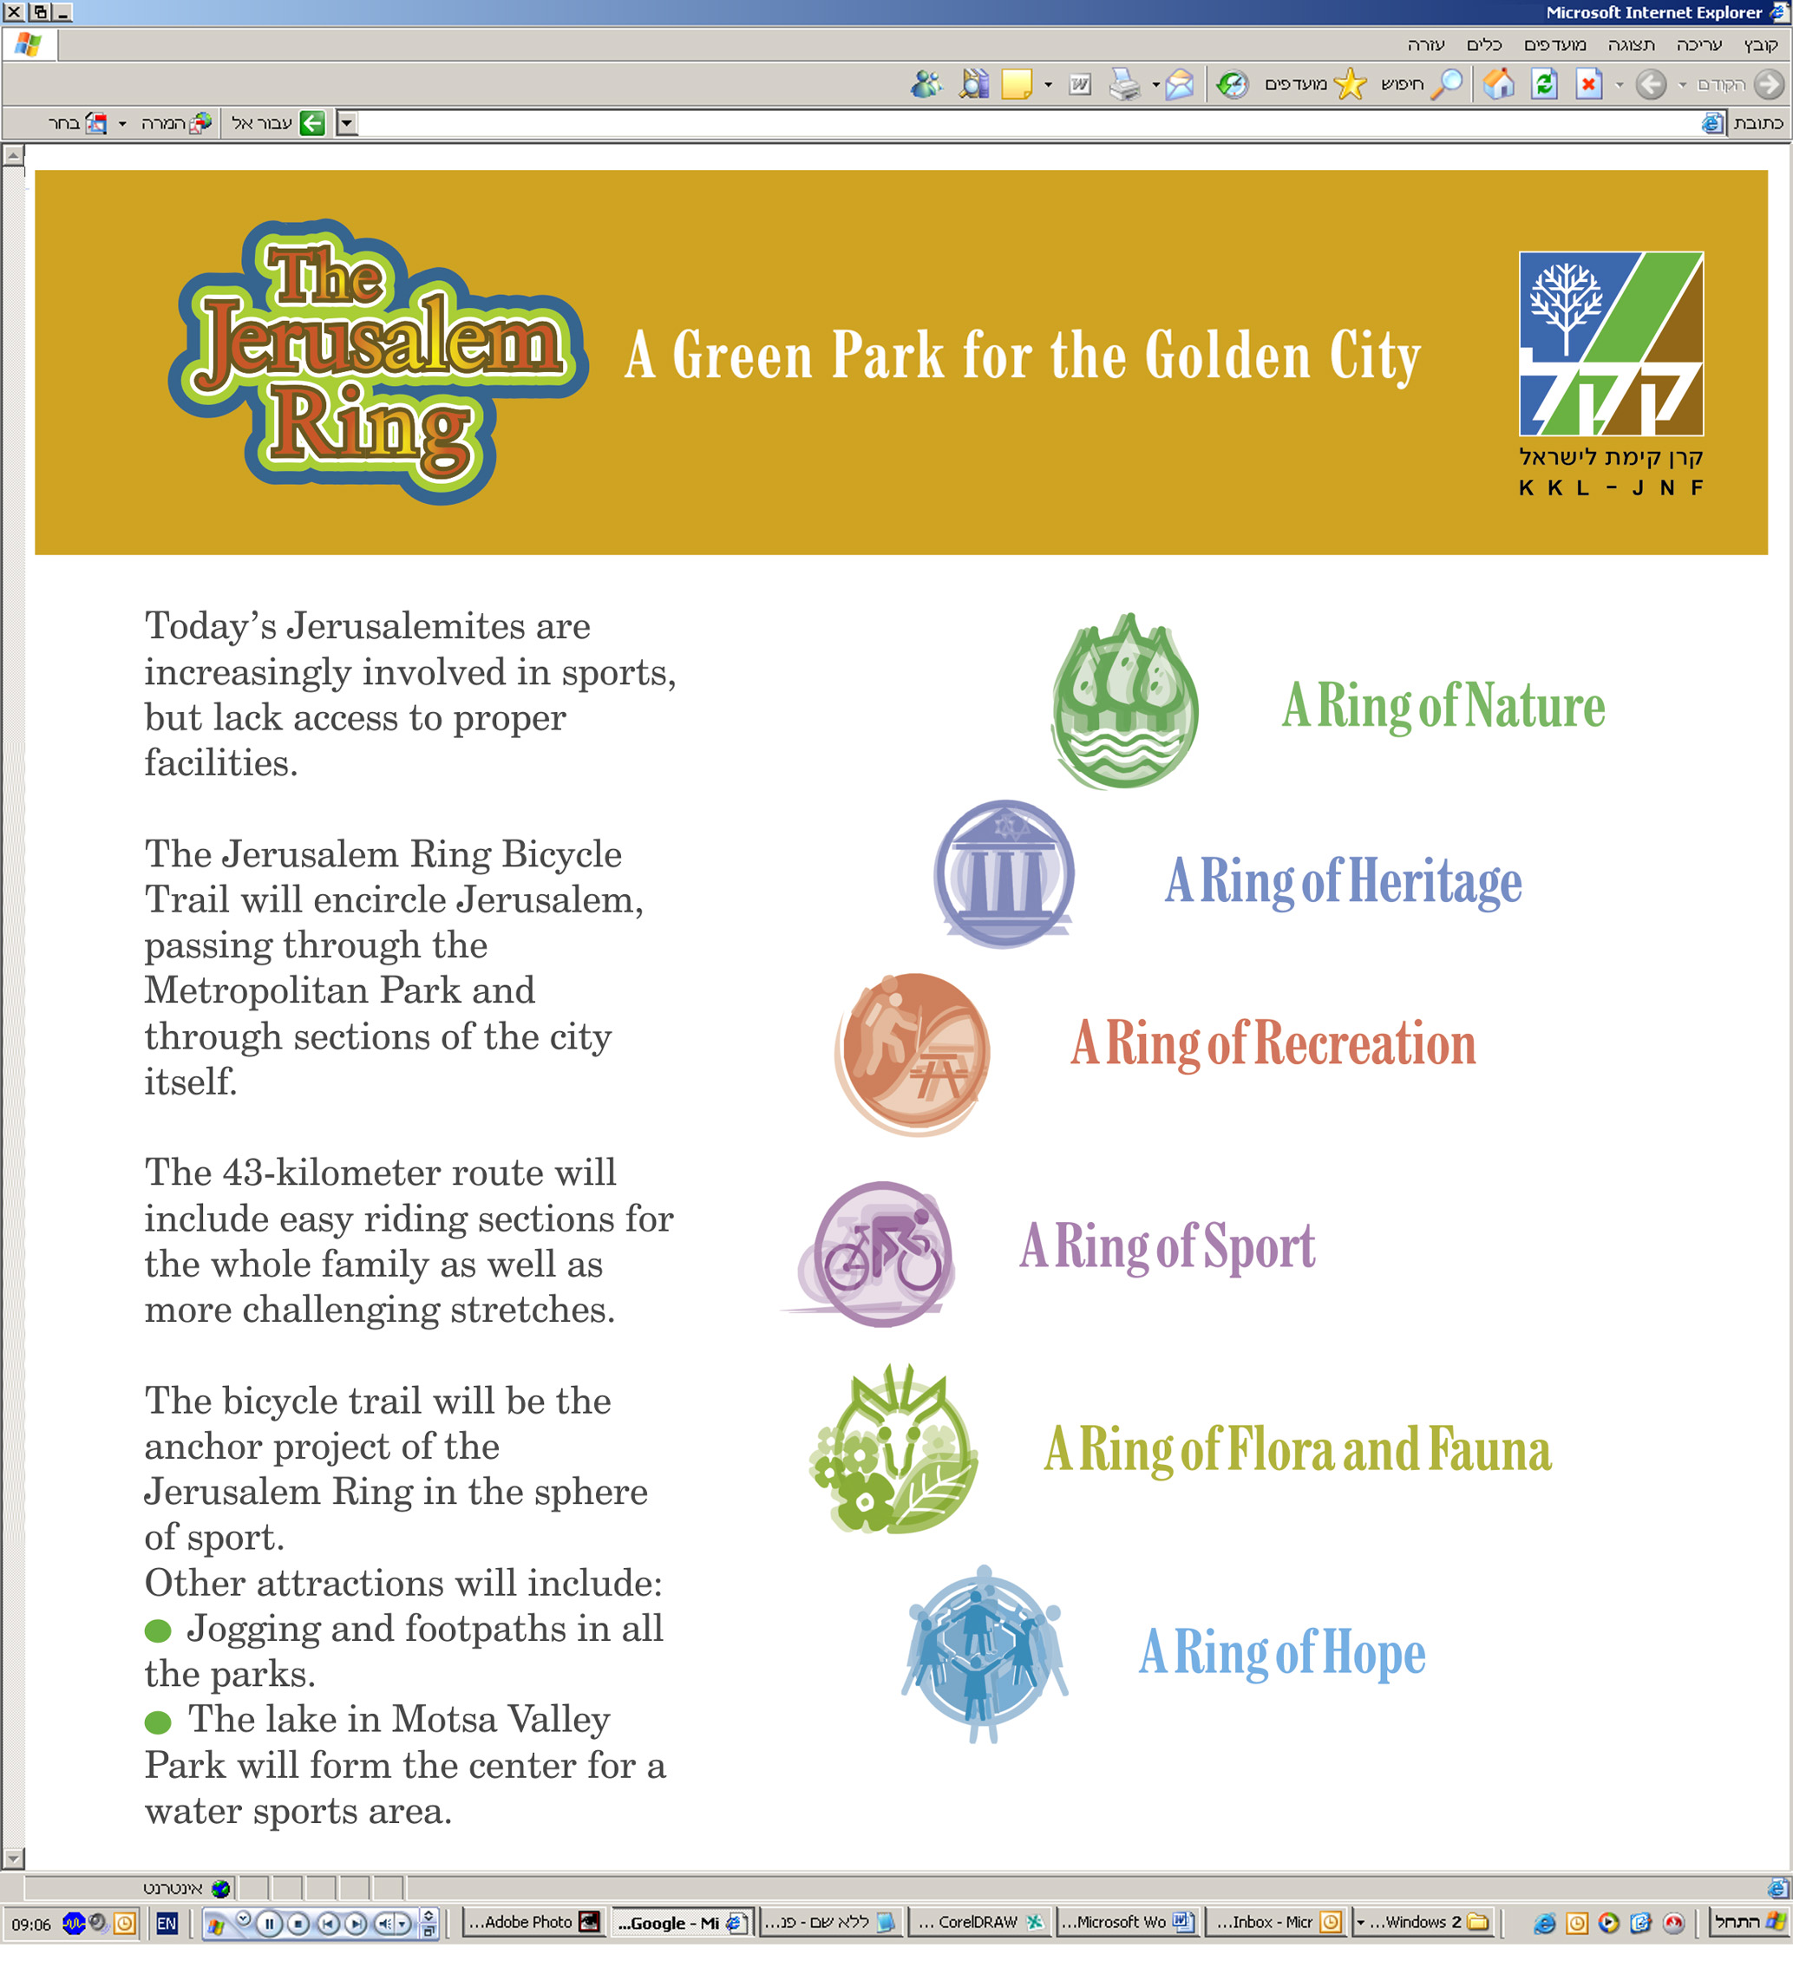
 Donor Certificates
Donor recognition should be based on rings according to the size of the donation – e.g. bronze ring – silver ring – gold ring – diamond ring, etc. See page 4 for an example of a certificate.
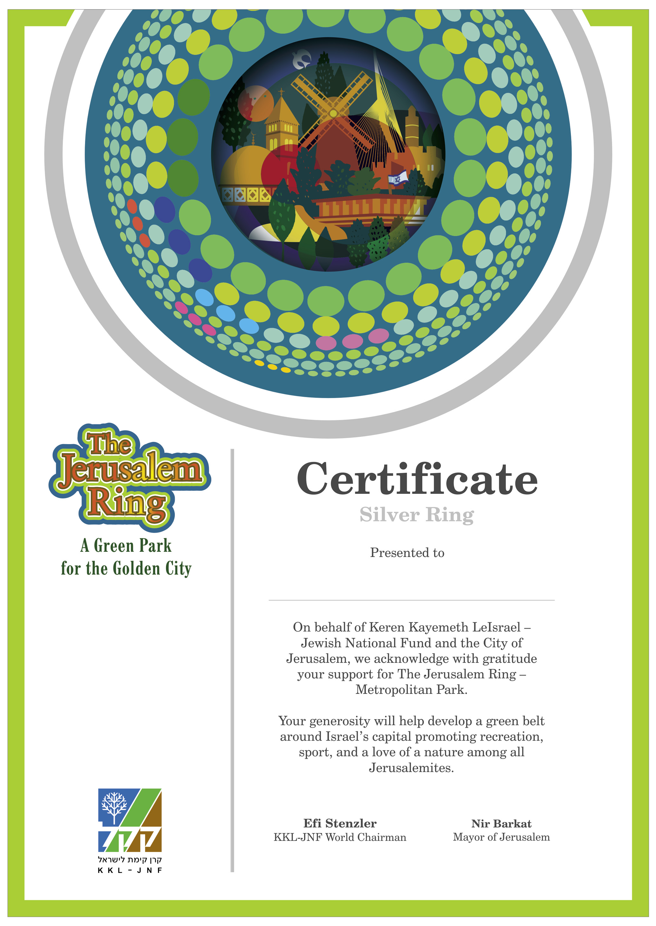
 Jerusalem quotes
"Ten measures of beauty descended to the world, nine were taken by Jerusalem." Talmud: Kiddushin 49b

"If I forget thee, O Jerusalem, let my right hand forget its skill! If I do not remember thee, let my tongue cling to the roof of my mouth-- if I do not exalt Jerusalem above my chief joy." Psalms 137:5-6

"Whoever did not see Jerusalem in its days of glory, never saw a beautiful city in their life." Talmud: Succah 51b

"'Eternity' - this refers to Jerusalem" Talmud: Berachot 58a
"To what does 'In the city of Gold' refer? To the Golden Jerusalem (crown) like that that Rabbi Akiva made for his wife." Talmud: Shabbat 59a
"The trees of Jerusalem were of cinnamon, but when it was destroyed, they were hidden away." Talmud: Shabbat 63a

"Jerusalem will only be redeemed through [the merit of giving] charity." Talmud: Shabbat 139a

"Each and every acacia tree that the gentiles removed from Jerusalem, will be restored to it by the Holy One, Blessed be He, in the future."
Talmud: Rosh Hashana 23a

"Jerusalem is like a city that people are friendly together - A city in which all [the people of] Israel are friends when the tribes ascend there for the pilgrimage." Talmud Yerushalmi: Hagiga 3

"For three thousand years, Jerusalem has been the center of Jewish hope and longing. No other city has played such a dominant role in the history, culture, religion and consciousness of a people as has Jerusalem in the life of Jewry and Judaism. Throughout centuries of exile, Jerusalem remained alive in the hearts of Jews everywhere as the focal point of Jewish history, the symbol of ancient glory, spiritual fulfillment and modern renewal. This heart and soul of the Jewish people engenders the thought that if you want one simple word to symbolize all of Jewish history, that word would be 'Jerusalem'." Teddy Kollek, Jerusalem, (DC: Washington Institute For Near East Policy, 1990), pp. 19-20.

"Without Jerusalem, the land of Israel is as a body without a soul."
Elhanan Leib Lewinsky (1857-1910), Hebrew writer and Zionist leader

"No city in the world, not even Athens or Rome, ever played as great a role in the life of a nation for so long a time, as Jerusalem has done in the life of the Jewish people." David Ben-Gurion, 1947

"In the din and tumult of the age, the still small voice of Jerusalem remains our only music." Israel Zangwill, 1921

"One prayer in Jerusalem is worth 40,000 elsewhere." Islamic Saying

"As the mountains surround Jerusalem, so the LORD surrounds His people from this time forth and forever." Psalms 125:2

"I returned to Jerusalem, and it is by virtue of Jerusalem that I have written all that God has put into my heart and into my pen." Shmuel Y. Agnon, Nobel Literature Laureate

"The view of Jerusalem is the history of the world; it is more, it is the history of earth and of heaven." Benjamin Disraeli

